Department course scheduling assistant

Software Requirements Specification

Version 3.0

December 06 2016

Team-D Sigma

**Nitheesha Kotagiri**

**Harika Malempati**

**Nikhil Kumar Vemula**

**Sai Kiran Gandham**

**Sravya Kandepu**

**Sanket Devrao Selokar**

**Prepared for**

**Graduated Directed Project - I**

**Instructor: Dr. Michael Oudshoorn**

**Fall 2016**

**Revision history:**

|  |  |  |  |
| --- | --- | --- | --- |
| **Date** | **Version** | **Description** | **People** |
| October 07, 2016 | 1.0 | First draft | **Project Owner and Client:**  Dr. Michael Oudshoorn  **Faculty Advisor:**  Dr. Michael Oudshoorn  **Project Group:**  Nitheesha Kotagiri  Harika Malempati  Nikhil Kumar Vemula  Sai Kiran Gandham  Sravya Kandepu  Sanket Devrao Selokar |
| November 15, 2016 | 2.0 | Second draft  Updated prototypes and usecases. | **Project Owner and Client:**  Dr. Michael Oudshoorn  **Faculty Advisor:**  Dr. Michael Oudshoorn  **Project Group:**  Nitheesha Kotagiri  Harika Malempati  Nikhil Kumar Vemula  Sai Kiran Gandham  Sravya Kandepu  Sanket Devrao Selokar |
| December 06, 2016 | 3.0 | Third draft  Updated use case and prototypes. Added new functionality like adding and deleting the faculty. | **Project Owner and Client:**  Dr. Michael Oudshoorn  **Faculty Advisor:**  Dr. Michael Oudshoorn  **Project Group:**  Nitheesha Kotagiri  Harika Malempati  Nikhil Kumar Vemula  Sai Kiran Gandham  Sravya Kandepu  Sanket Devrao Selokar |

**Document approval:**

The following Software Requirements Specification has been accepted and approved by the following:

|  |  |  |  |
| --- | --- | --- | --- |
| **Signature** | **Printed Name** | **Title** | **Date** |
| Saikiran Gandham | Saikiran Gandham | Client Manager | 11/15/2016 |
|  | Dr. Michael Oudshoorn | Faculty Advisor |  |
|  | Dr. Michael Oudshoorn | Project Sponsor |  |
| Saikiran Gandham | Saikiran Gandham | Client Manager | 12/06/2016 |
|  | Dr. Michael Oudshoorn | Faculty Advisor |  |
|  | Dr. Michael Oudshoorn | Project Sponsor |  |

#### **Table of Contents**

**1. Introduction** 1

**1.1 Purpose** 1

**1.2 Scope** 1

**1.3 Definitions** 1

**1.4 Overview** 2

**2. General Description** 3

**2.1 Product Perspective** 3

**2.2 Product Functions** 3

**2.3 User Characteristics** 3

**2.4 General Constraints** 4

• Faculty cannot teach in two places at same time. 4

**2.5 Assumptions and Dependencies** 4

**3. Specific Requirements** 5

**3.1 External Interface Requirements** 5

3.1.1 User Interfaces 5

Feature #1: User login 5

Feature #2: Forgot Password Page 6

Feature #3: Faculty Home Page 7

Feature #4: Faculty Course Page 8

Feature #5: Faculty Calendar Page 9

Feature #6: Administrator Home Page 9

Feature #7: Faculty Add Page 10

Feature #8: Faculty Delete Page 11

Feature #9: Administrator scheduler screen 12

Feature #10: Scheduler Conformation page 13

3.1.2 Hardware Interfaces 14

3.1.3 Software Interfaces 14

3.1.4 Communications Interfaces 15

**3.2** **Requirement Traceability Matrix:** 15

**3.3 Use cases** 15

3.3.1 Common use cases for each user 15

**3.4 Non Functional Requirements** 27

3.4.1 Performance 27

3.4.3 Availability 27

3.4.4 Security 27

3.4.5 Maintainability 27

**4. Analysis Models** 28

**4.1 Data Flow Diagram (DFD):** 28

**5. Change Management Process** 29

**6. Client Acceptance** 30

# **1. Introduction**

This document is to present the purpose, scope and functional and non-functional requirements which we are going to be implemented during the development of the project. This document will give an overview of the application.

## **1.1 Purpose**

The purpose of this document is to give an outline of the application and it’s working to all the team members and the client.

## **1.2 Scope**

The project is about developing an application titled “Department course scheduling assistant”. Our application helps University administrator to schedule and view classes in two ways like course wise scheduling and faculty wise scheduling. Faculty can view his/her class schedules and represents in graphical user interface and also the schedules of other faculty who are teaching in the university and also solving the conflicts of other faculty who are teaching same course. The idea of the application evolved mainly to easy the process of scheduling classes by considering all the limitations and priorities of all the faculty members.

## **1.3 Definitions**

|  |  |
| --- | --- |
| **Term** | **Definition** |
| Database | A collection of all the information monitored by this system. |
| Software Requirements Specification (SRS) | A document that completely describes all of the functions of a proposed system and the constraints under which it must operate. |
| Stakeholder | Any person with an interest in the project. |
| User | The person who uses the application seeking help. |
| Scheduler | A Person who schedule classes for faculty. |
| Use cases | Graphical representation of flow in project. |
| Mockups | Sample User Interfaces of the project. |
| Server | Web Server which handles request send by the user and sends back the response. |

## **1.4 Overview**

This document provides an outline of the system functionality and system interfaces and interaction. Further, non-functional requirements, use cases, software and hardware interfaces and other requirements of the project.

# **2. General Description**

This section will give an overview of the whole application. This section describes the perspective of the product, the basic functions, and the types of users that will be using the application, the constraints and the assumptions.

## **2.1 Product Perspective**

The main goal of this web project is to provide an effective user interface to schedule the courses in Northwest Missouri State University.

The “Department course scheduling assistant” application is mainly useful for university authorities to schedule the classes easily and faculty can view their schedule in an interactive way. University Administrator and Faculty can access this application.

## **2.2 Product Functions**

In this application administrator can login with credentials, provided by the university. If user forgot his/her password, he/she can click on the “forgot password” link on the login page, as a result a notification user’s university email I’d to reset his/her password. Once the user logs in, user will be navigated to home page. User can access multiple tabs in this page like scheduler, calendar view. Administrator can schedule classes by using scheduler tab by clicking on it and can view classes details using calendar view based on our priority like course wise view or faculty wise view. Faculty can also login to this application using his provided credentials. Faculty will be navigated to home page, where he can view calendar based on his priority like course wise view or faculty wise view. And at any point of time the user can logout by clicking on the logout button.

## **2.3 User Characteristics**

There are two types of users that interact with this application – administrator user and faculty user.

The Administrator user is the one who’s having permissions to schedule the classes and he acts like responsible person for all scheduling tasks. The Administrator user assign faculty to different courses based on their requirement criteria and limitations of that faculty like subjects he/she teach , hours he/she works.

The Faculty are the one who can view his classed schedule like class’s timings, lab session timings. Faculty can also view other faculty schedules.

## **2.4 General Constraints**

## Faculty cannot teach in two places at same time.

* Two classes can’t be scheduled at same time in same room.
* Number of sections is determined based on number of students enrolled each semester.
* Updating number of sections as soon as section is scheduled, indicating how many sections are still needed to be scheduled.
* Updating required number of credit hours for faculty as soon as class is scheduled, if faculty has reached credit hour limit he/she is not allowed to be scheduled for more classes, this is done by showing an alert message on the user interface application.

## **2.5 Assumptions and Dependencies**

The assumptions about the product is that it can also be used only for desktop only. If server gets down or in poor internet connection situation, it is not possible to use this application. Only authorized persons can use this application. University will supply the login credentials for the admin and faculty.

# **3. Specific Requirements**

## **3.1 External Interface Requirements**

### 3.1.1 User Interfaces

### Feature #1: User login

**Requirements:**

Once the webpage is launched the first display in the screen faculty will be directed to login page. In user login page user need to enter his/her credentials and these credentials will be validated in the database and the authentication for login will be provided.

**Input:**

User need to enter his/her credentials i.e. Username and password and need to click/select login button to login.

**Description:**

1. User need to provide username and password to login.

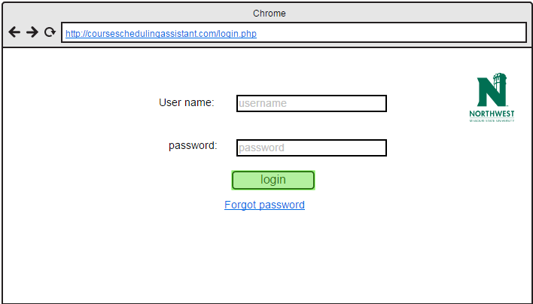

**Outputs:**

If user is faculty he/she will be redirected to faculty home page. If user is administrator he/she will be redirected to administrator home page. If the administrator is a faculty then he is provided with the administrator rights.

**Error Handling:**

If the provided login credentials are wrong or forget to enter credentials and click login an error is thrown.

If user forgot his/her password then he/she should click on forgot password link.

### Feature #2: Forgot Password Page

**Introduction:**

In user clicks on forgot password link then this page will be displayed.

**Inputs:**

1. User will enter email id and new password.

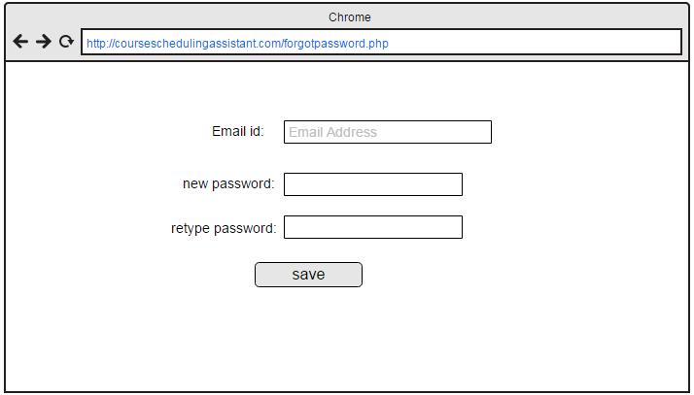

**Outputs:**

It reset password of user.

### Feature #3: Faculty Home Page

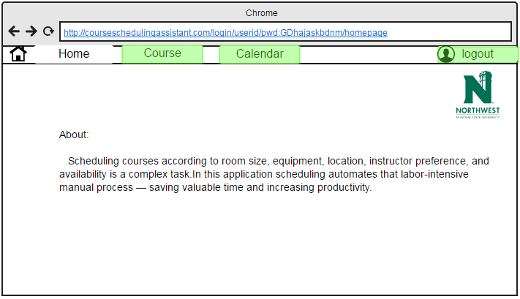

**Introduction:**

In faculty home page there will be calendar and course buttons. Those 2 buttons will be redirected to faculty course page and faculty calendar page.

**Inputs:**

1. In this page faculty/user will not enter any data. He/she need to click button depending on his requirement.
2. Faculty has to click on course button or calendar button to view his schedule.

**Description:**

If user is faculty he/she will be redirected to faculty home page. If user is administrator he/she will be redirected to administrator home page.

**Outputs:**

If faculty clicks on the course button he/she will be redirected to course page. If he/she clicks on calendar it will be redirected to calendar page.

### Feature #4: Faculty Course Page

**Introduction:**

In faculty course page, faculty will select subject for which he/she going to see the schedule.

**Inputs:**

1. User/faculty has to select a subject from dropdown.
2. In this page user/faculty has to click course view or view schedule after selecting subject.

**Description:**

User need to select subject from dropdown menu and he/she has to click on the course view or on the view schedule.

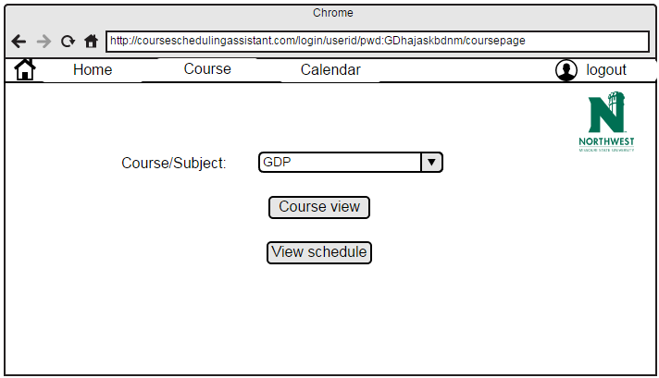

**Outputs:**

1. If user clicks on course view it displays information about particular course in calendar.
2. If user clicks on the view schedule it displays timetable of the professor.
3. The faculty can view all the scheduled class of the department.

**Error Handling:**

If user did not select subject from dropdown menu, it displays alert message.

### Feature #5: Faculty Calendar Page

**Introduction:**

In faculty course page, faculty will select subject then this page will be displayed.

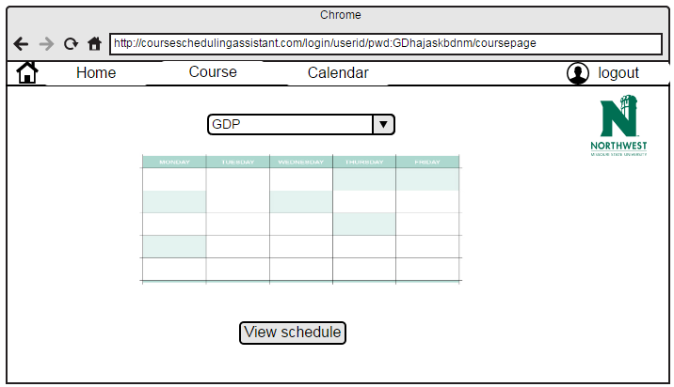

**Output:**

Schedule of the subject displayed in calendar format.

### Feature #6: Administrator Home Page

**Introduction:**

If user is administrator who has the responsibility to schedule classes for professors.

**Inputs:**

In this page administrator will be seeing description about university and he/she need to select scheduler button to schedule a class or he/she can select course button to see the information about the course.

**Description:**

This page is the administrator home page.

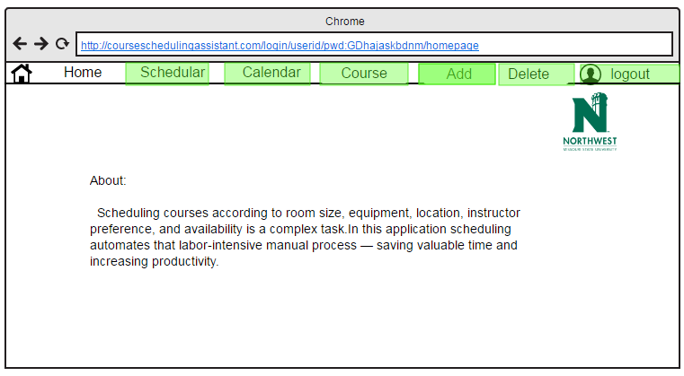

**Outputs:**

User can view description and images about the university.

### Feature #7: Faculty Add Page

**Introduction:**

If admin wants to add professor the list of professors.

**Inputs:**

Admin will enter details of professor like name and email address and type (full time or part time) and clicks on the Add professor button.

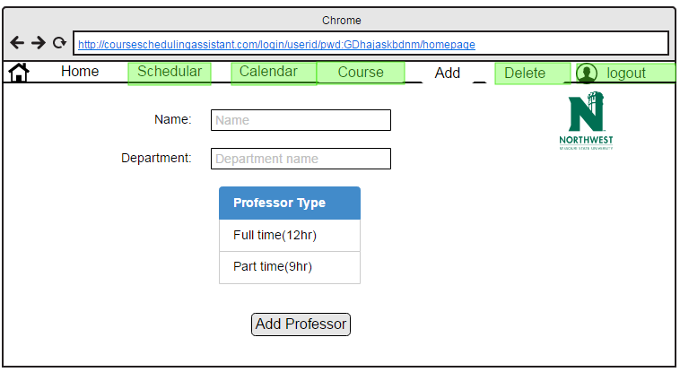

**Output**:

Professor will be added to the list.

**Error Handling:**

If administrator did not entered the data in given fields, pop up message will be displayed.

### Feature #8: Faculty Delete Page

**Introduction:**

If admin wants to delete professor from the list of professors.

**Inputs:**

Admin will enter details of professor like name and department name and clicks on the delete professor button.

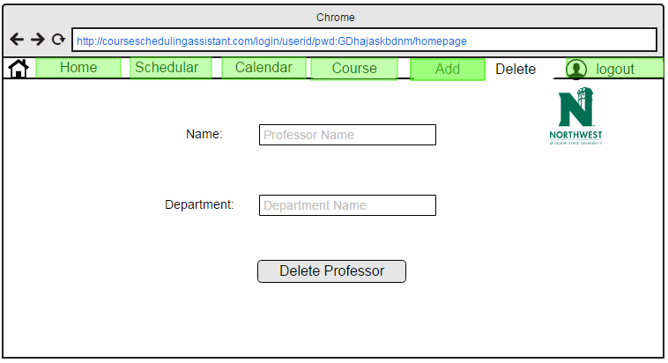

**Output:**

Professor will be deleted from the list.

**Error Handling:**

If administrator did not entered the data in given fields, pop up message will be displayed.

If given data is incorrect (i.e., given name does not matches from given list) then pop up message will be displayed.

### Feature #9: Administrator scheduler screen

**Introduction:**

When user click on the scheduler button this page will be displayed.

**Inputs:**

In this page administrator has to select by clicking the items such as campus location, department, faculty name, course and number of days (professor is going to teach in week).

**Description:**

In this administrator is going to schedule class for professor.

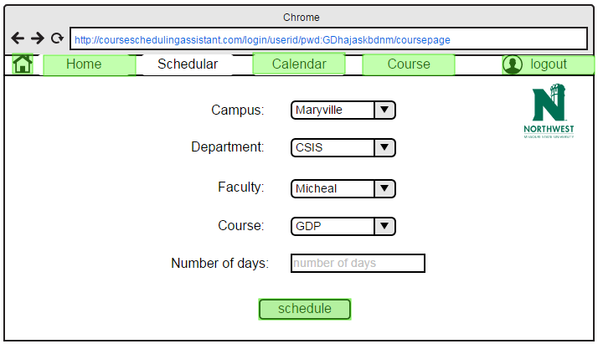

**Outputs:**

After giving inputs in the boxes and clicks on the set schedule button, then this page will redirected to another conformation page.

**Error Handling:**

If administrator did not enter any value, it displays alert message to enter mandatory fields.

### Feature #10: Scheduler Conformation page

**Introduction:**

If administrator clicks on the set schedule button on the scheduler page this page will be displayed.

**Inputs:**

If administrator can select set schedule button or he/she can cancel the process.

**Description:**

This page is to conform about the details given in previous page and to select class room.

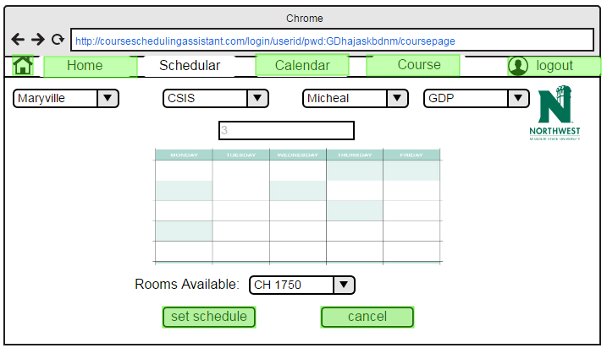

**Outputs:**

After checking all fields and clicking on the set schedule class will be allotted to professor and displays calendar view of particular course.

**Error Handling:**

If administrator did not enter the room number, an alert message is displayed.

### 3.1.2 Hardware Interfaces

The hardware interfaces required for this application are – Desktop or laptop with windows Operating system, 2 GB RAM and 250 GB memory. The device should also have internet.

### 3.1.3 Software Interfaces

Before we start developing a web based application in, we need to setup software development environment for that we need to have following tools.

* NetBeans IDE
* Windows system
* Advanced java script
* Enrollment into Java developer program
* Testing tools

### 3.1.4 Communications Interfaces

The Department course scheduling assistant application shall use the HTTP protocol for communication over the internet and for the intranet communication will be through TCP/IP protocol suite.

## **Requirement Traceability Matrix:**

|  |  |  |  |  |
| --- | --- | --- | --- | --- |
| **Requirement No.** | **Name** | **Category** | **Source** | **Status** |
| **1** | Laptop and memory | Hardware | Software Requirement specification. | Every laptop must have a memory of at least 32GB of memory |
| **2** | Application developers | Human resource | Project charter and management plan | Require software developers for developing application. |
| **3** | Application testers | Human resource | Project charter and management plan | Require for testing application. |
| **4** | MS project | Software | Time management | To develop the Gantt chart. |
| **5** | Software Environment | Software | Software Requirement specification | To develop application. |

## **3.3 Use cases**

This section describes the use cases of different users in this project. Different users of this application are university administrator and faculty.

### 3.3.1 Common use cases for each user

## 

1. **Login Page:**

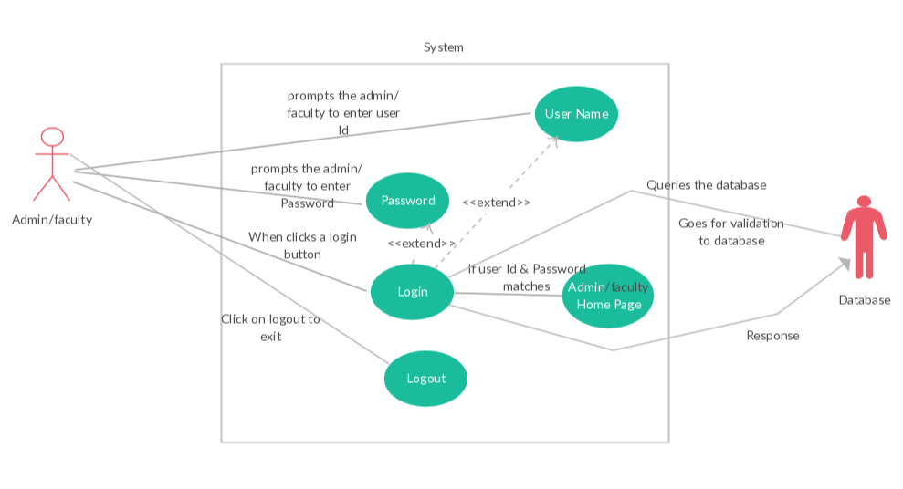

Description:

Login details should need to be provide to access the page. The login page is same for both Admin and Faculty with respect to their credentials the page will direct them to their respective home page.

1. Click on the user Id text field and enter the user Id.
2. Click on the password text field and enter the password.
3. Click on the login button.
4. The user Id & password will authenticated from the database and provides the user to login.
5. **Admin Home Page:**

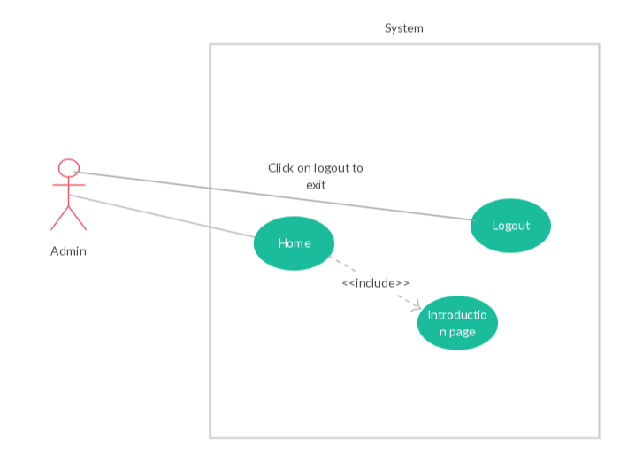

Description:

Admin provides the credentials and logs into the home page where he can find a button logout for exiting cite. The home page contains the general information of the university.

1. **Admin Scheduler Page:**

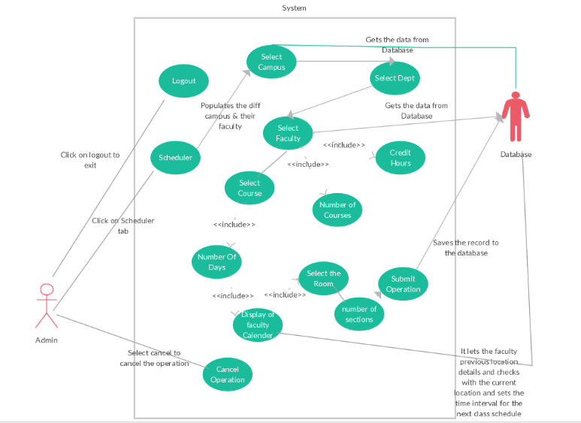

Description:

By clicking on the scheduler button in the home page it directs to this page and where the faculty schedule will be made. There are few steps in this process they are.

1. Select the campus where the faculty need to teach.
2. Select the department of the subject.
3. Select the faculty from the list which is provided under the department.
4. Enter the number of credit hours the faculty is teaching.
5. Enter the number of subjects that particular faculty is teaching.
6. Now select the course of the faculty.
7. Enter the number of days the faculty want teach with a weak.
8. Now with the available details display the free time of the faculty and select the time.
9. After the selection now we will for the available room for that subject and book the room.
10. Finally if all the credentials are correct click on submit else you can cancel the operation by clicking on the cancel button.
11. **Admin Calendar Page:**

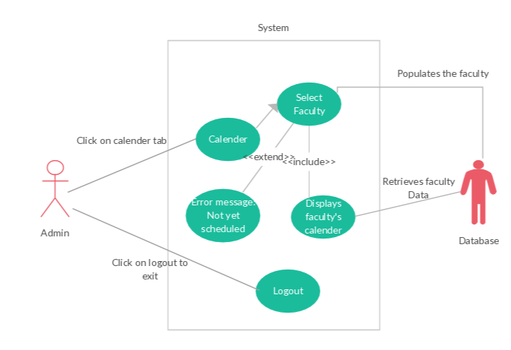

Description:

By clicking on the Calendar button it directs you to this page. It will displays the calendar of each faculty. Select the faculty from the list to whom you want check the calendar. If he doesn’t have any schedules then it popups an error message “Not yet scheduled” and if he is scheduled then it displays the calendar of that faculty.

1. Click on the calendar button
2. Select the faculty from the drop down list.
3. If the faculty has schedule then it displays the calendar else it through an error message ”Not yet scheduled”
4. **Admin Course Page:**

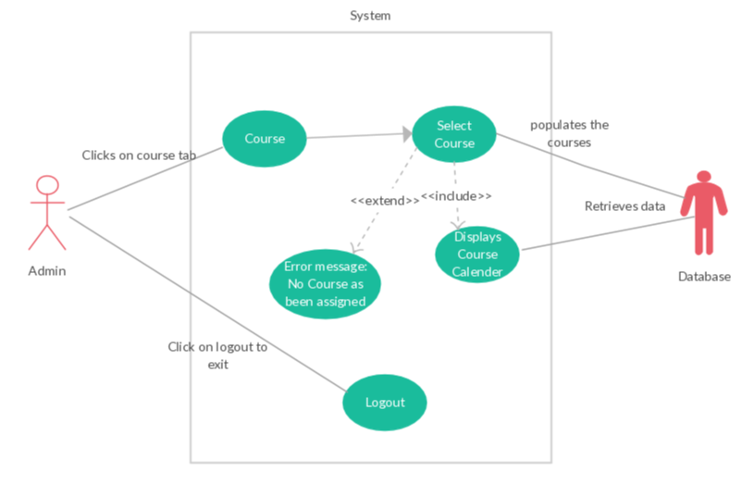

Description:

Course button will be displayed on the home page by clicking on the button it will direct you to this page. This page displays the calendar of the individual course and how many faculty are teaching this course and what are the timing for that course.

By selecting the course from the list displayed it will display the calendar of the course. If there is no course scheduled then an error message “No course has been assigned” will display.

1. Click on the Course button.
2. Select the course
3. If the course has schedule then it displays the calendar else it through an error message ”Not yet scheduled”.
4. **Faculty Home Page:**

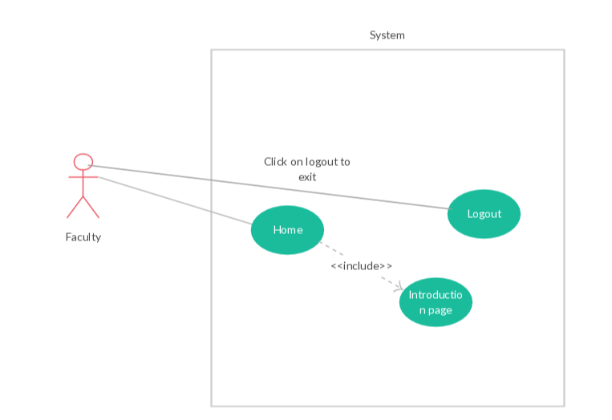

Description:

Faculty provides the credentials and logs into the home page where he can find a button logout for exiting cite. The home page contains the general information of the university.

1. **Faculty Calendar Page:**

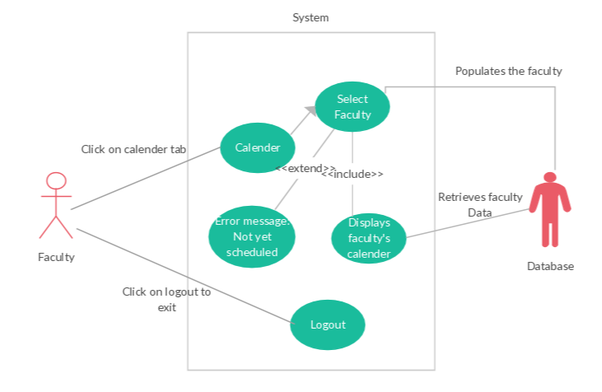

Description:

By clicking on the Calendar button it directs you to this page. It will displays their calendar with course details. If he doesn’t have any schedules then it popups an error message “Not yet scheduled” and if he is scheduled then it displays the calendar of that faculty.

1. Click on the calendar button
2. If the faculty has schedule then it displays the calendar else it through an error message ”Not yet scheduled”
3. **Faculty Course Page:**

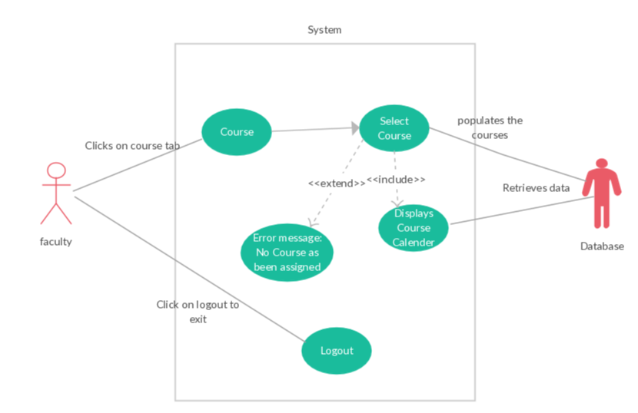

Description:

Course button will be displayed on the home page by clicking on the button it will direct you to this page. This page displays the calendar of the individual course and how many faculty are teaching this course and what are the timing for that course.

By selecting the course from the list displayed it will display the calendar of the course. If there is no course scheduled then an error message “No course has been assigned” will display.

1. Click on the Course button.
2. Select the course
3. If the course has schedule then it displays the calendar else it through an error message ”Not yet scheduled”.
4. **Adding a Faculty:**

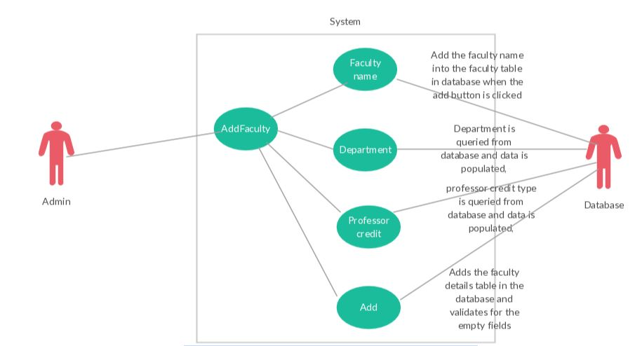

Description:

Whenever a new faculty joins the school, the admin will add the faculty details to the database.

1. Admin will add the new faculty by clicking on the Add Faculty button.
2. Faculty name, department and professor teaching credits will entered and click on add button.
3. And then the faculty will be added to database.
4. **Deleting a Faculty:**

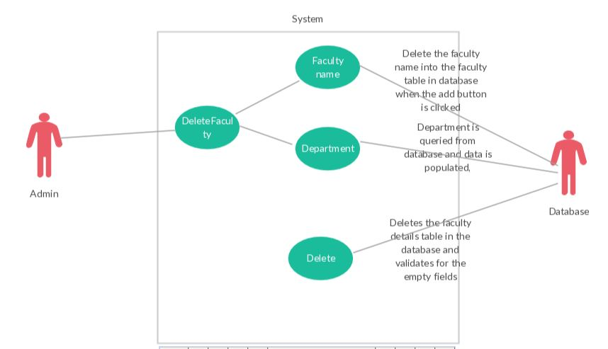

Description:

Whenever a faculty leaves the school, the admin will delete the faculty details from the database.

1. Admin will delete the existing faculty by clicking on the delete Faculty button.
2. Faculty name and department will entered and click on delete button.
3. And then the faculty will be deleted.
4. **Location validation:**

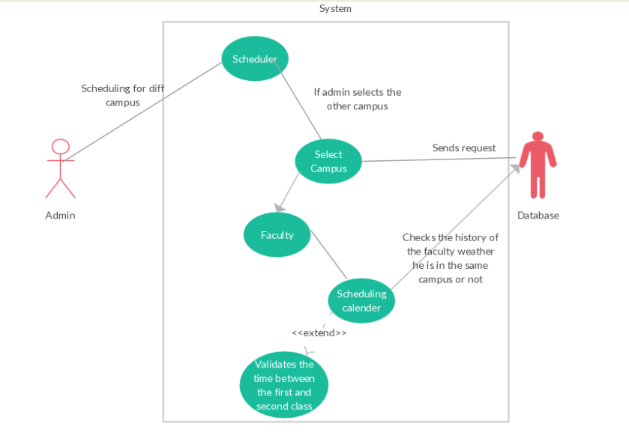

Description:

While admin scheduling the time table for the faculty, he selects the campus and then the faculty and after that the scheduling calendar of the faculty will be displayed.

While selecting the campus the database will check the previous teaching location of the faculty and if it is not at the same location then the travelling time for the next class will be deactivated so that the faculty will have some time to travel the distance between the two campuses.

## **3.4 Non Functional Requirements**

### 3.4.1 Performance

The system should be able to show the classes and its timings for faculty in course wise view and in faculty wise view. The system should show the scheduled classes to Admin in two ways, in addition to that Admin can able to schedule class’s course wise and faculty wise based on the requirements and limitations.

**3.4.2 Reliability**

System is reliable in terms of scheduling classes by admin, viewing the classes by both admin and faculty.

### 3.4.3 Availability

The app is available to both the users.

### 3.4.4 Security

All the user information data can able to fetch from database so there is no chance for fault misrepresentation, every user is provided a unique credentials, so that only authorized persons can access this web application.

### 3.4.5 Maintainability

The system can be flexible to add more functionality in future. System can be tested.

# **4. Analysis Models**

## **4.1 Data Flow Diagram (DFD):**

A data flow diagram (DFD) is a graphical representation of the "flow" of data through an information system



This data flow diagram explains the top down approach of our application. In above diagram left part describes when user is admin and right side is the faculty view. Rectangular boxes in the above diagram represents input given by user (admin/faculty) which together provide all of the functionality of the system as a whole. It also identifies internal data stores that must be present in order for the system to do its job, and shows the flow of data between the various parts of the system.

# **5. Change Management Process**

1. All the changes in the requirements will be initially discussed with our instructor and will be documented as a minor version.
2. The modified document will be sent to the client for approval.
3. This document will be published as a major version only after the approval from the client.

# **6. Client Acceptance**



Date: December 06, 2016